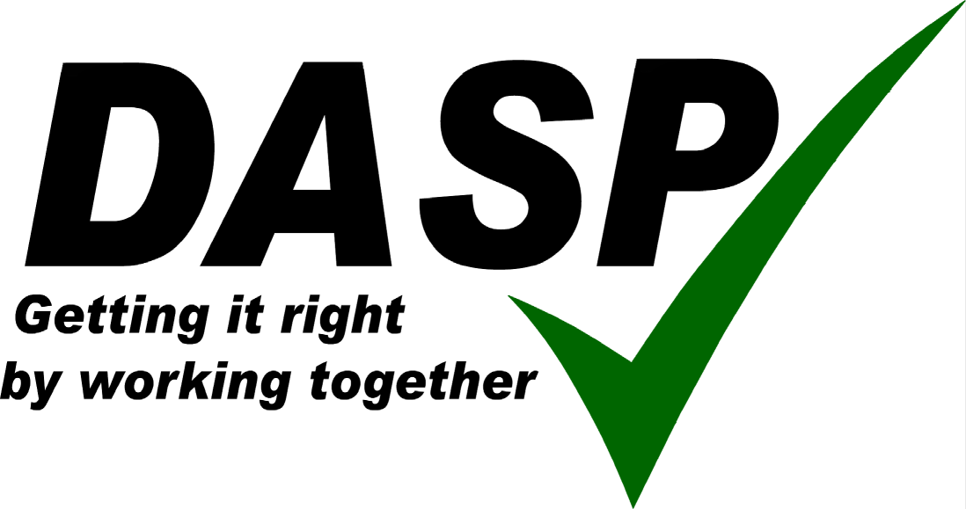
Let’s be careful Out there!

A Parents guide to being safe and secure on the Internet.

There are many, many positive aspects to children using the internet. When we become aware of the possible problems, we should not panic and withdraw all access. A responsible, caring attitude will ensure that the problem does not merely get ‘shifted’ somewhere else. The main areas of concern for us are the Social Networking sites, as these are the fastest growing area of internet use by young people and ‘cyberbullying’.

Social Networking Sites

These sites allow children to communicate and share interests. They can set up groups of like minded people (for example fans of a particular pop group). Users can upload photos of themselves to their ‘space’. Social Networking sites allow the children to display creativity, as well as develop IT skills. Typical sites are:

YouTube - Users can upload videos to this space.
Bebo - Children create a space of their own, where they can register their interests and communicate with other children. They can post photos and videos here that others can see.
FaceBook - Similar to Bebo, more popular now with older children.
MSN - Instant communication site, children send messages to each other to ‘chat’ and can also use webcams for sound and image.
My Space - A place for people to ‘deposit’ contents such as music and video for sharing. Musicians often use this area to promote their work.
Habbo Hotel - A 3D world where children can ‘travel’, meeting others. They should normally be using an alias, not their own name.
Second Life - Similar to above, but adult orientated.
Club Penguin - A Disney site, for younger children, where they take on the identity of a penguin and can ‘talk’ to other penguins.

Most of the services above have a starting age limit of 13, but this is not strenuously checked and is easily subverted by children. They also have some limited protection, if the user chooses to implement it. However, not all these sites have always shown social responsibility for the consequences of their product.

The Danger: children, whilst being technically very savvy, may be over confident and not careful about who they share information with. They may leave themselves open to abusers and they cannot be sure that it is a young person they are communicating with. The amount of personal information they make available can help someone build up a profile about them. These sites can also be a contributing factor in identity theft.

Cyberbullying

Cyber bullying is an element of bullying itself and not a separate issue. It is a relatively new concept, but is growing fast. It can be done via computer e-mail, chatrooms, forums or texting on a mobile. In a 2005 survey, 20% of children say they have been the subject of cyber bullying (14% by texting). 11% admitted sending threatening messages. Cyber bullying tends to be more common outside, than inside school. A third of victims don’t tell anyone about what has happened. Some studies indicate that girls use texting for bullying, far more than boys do. Social Networking sites are also being used for bullying, with hate messages and images. With cyber bullying there is no place to hide. With ‘traditional’ bullying the victim can at least go home and hopefully feel safe. Cyber bullying comes into the home and cannot be escaped. Because of the remote nature of this bullying, it can be more widespread, as the perpetrator doesn’t really think about the consequences of their actions, because they are not face to face with the victim. They may also believe, mistakenly, they have some anonymity through the technology. Frequently, the situation that leads to the bullying will begin in school. However, just removing or banning the technology doesn’t solve the problem, just moves it somewhere else. Education about the consequences of cyber bullying will be more effective.

Identity Theft

There has been much publicity about this, although it is usually a financially based crime and so does not affect young children so much. However, they should be aware that personal details put on a website, can be used by other people to set up a bank or shop account, or perhaps obtain a passport. Care should always be used when buying online. Look for the padlock symbol on a webpage to ensure it is ‘encrypted’ (should be safe from hacking). Don’t respond to e-mails asking for bank details, or that say you have won fantastic prizes. Remember, if its sounds too good to be true, it probably is! Never put passwords or financial details in an e-mail.

What can Schools do?

All DASP Schools have an Internet Acceptable Use Policy (AUP). This sets down how students and staff can use the internet in school, All schools in Dorset are part of the South West Grid for Learning (SWGfL) which administers our internet service. This includes filtering of the internet, to ensure that unsuitable images or language are not transmitted. This can never be 100% efficient, but studies have shown that South West schools probably have the best protected internet provision in the country. Children cannot access sites such as YouTube, Facebook and Bebo at school. School E-mail is provided through a safe system administered by Education provider, Research Machines. As we become more aware of areas for concern, we can provide children with information and support for safer internet use. By showing them how to use the internet responsibly at school, we can help in their awareness for use at home.

What can children do?

This button appears on a number of websites now (and at www.thinkuknow.co.uk). It allows children to report directly to specially trained police officers, if they have any suspicions of people being inappropriate towards them. Children and young people should always be encouraged to talk about what they are doing on the internet and never be afraid to share concerns with a trusted adult. They should also save the www.thinkuknow.co.uk website to their favourites - this will allow them to get advice and guidance or use the report abuse button, with only one click.

What can Parents Do?

Watch what your children do on the internet, but don’t ‘spy’. Ask questions to show you are interested in what they do online. The Child Exploitation and Online Protection (CEOP) Centre recommends that any computers should be kept in a family room, such as a lounge or dining area. Children are less likely to engage in risky behaviour if they know their parents are near by and if ‘predators’ can see adults in the background, they will probably stay away. Parents are also encouraged to visit the www.thinkuknow.co.uk/parents website - where they can register to receive monthly emails, giving them up to date information on new and emerging technologies and how to keep their children and families safe online.

These are some ideas from the ThinkUKnow Parents website (see link below):

- Know what your children are doing online and who they are talking to. Ask them to teach you to use any applications you have never used.
- Help your children to understand that they should never give out personal details to online friends—personal information includes their messenger id, email address, mobile number and any pictures of themselves, their family or friends—if your child publishes a picture or video online—anyone can change it or share it.
- If your child receives spam/junk email & texts, remind them never to believe them, reply to them or use them.
- It's not a good idea for your child to open files that are from people they don't know. They won't know what they contain—it could be a virus, or worse - an inappropriate image or film.
- Help your child to understand that some people lie online and that therefore it's better to keep online mates online. They should never meet up with any strangers without an adult they trust.
- Always keep communication open for a child to know that it's never too late to tell someone if something makes them feel uncomfortable.
- Teach young people how to block someone online and report them if they feel uncomfortable.
The following are ‘Net speak’ acronyms that children can use when online. These might indicate that they are concerned about you seeing what they are doing!

POS - Parents over shoulder
TOS - Teacher over shoulder
PAW - Parents are watching
TIW - Teacher is watching
SAW - Siblings are watching
CTN - Can’t talk now
NP - Nosy parents
PA - Parent alert
PAL - Parents are listening
PAN - Parents are nearby

Useful internet Links – these will give you more information and support in understanding the possible areas for concern.

British Education and Communication Training Agency
http://schools.becta.org.uk/index.php?section=is

CBBC
http://www.bbc.co.uk/cbbc/help/safesurfing/

Child Exploitation and Online Protection Centre
http://www.ceop.gov.uk/

Childnet International
http://www.childnet-int.org/

Insafe - European network of e-safety awareness
http://www.saferinternet.org/ww/en/pub/insafe/index.htm
THINKUKNOW
http://www.thinkuknow.co.uk/

Virtual Global Taskforce
http://www.virtualglobaltaskforce.com/

This leaflet has been produced by Richard Scott – E Learning Manager for the Dorchester Area Schools Partnership.

